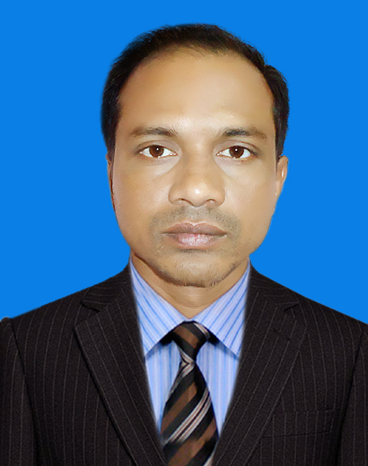
Curriculum Vitae

Md. Quamruzzaman
Cell: +880 1828 513076
E-mail: ssss

Personal Information
- Name : Md. Quamruzzaman
- Father’s name : Md. Sajedul Karim
- Mother’s name : Mrs. Nurjahan Begum
- Mailing Address : 154/1, Karim Mansion
Bhasani Road, Soyagobinda
Sirajganj- 6700
Bangladesh
- Permanent Address : DO
- Date of Birth : 15 September 1971
- Nationality : Bangladeshi
- Religion : Islam
- Height : 5′-3″
- Weight : 50 KG
- Blood Group : O+
- National ID No. :8827805131948
- Passport No. : BA0631799
- Marital Status : Separated
- Children : 2 (Male)

Family Information
- Name of son 1 : Muhammad Ibn Zaman
- Date of Birth : 04 April 1999
- Education Level : 13th Class
- Name of son 2 : Ahmed Ibn Zaman
- Date of Birth : 29 October 2004
- Education Level : 9th Class

Page: 1of 4
Educational Qualification

Name of Examination | GPA/Class | Passing Year | University/Board
Master of Arts (English) | 5.58 | 2011 | Darul Ihsan University, Bangladesh
Bachelor of Arts (Honours) | 5.55 | 2009 | Darul Ihsan University, Bangladesh
Bachelor of Social Science (Pass) | 2nd | 1998 | National University, Bangladesh
Higher Secondary Certificate | 1st | 1996 | Rajshahi Education Board, Bangladesh
Secondary School Certificate | 1st | 1987 | Rajshahi Education Board, Bangladesh

Work History

- 22 December 2013 - Till to date: have been serving for Sirajganj Collectorate School & College, (an International Standard English Medium Educational Institution) Sirajganj, Bangladesh as ‘Lecturer of English Language & Literature’ in Higher Secondary School level.

- 15 January 2004 – 21 December 2013: had been serving for the same institution as ‘Junior Lecturer of English Language & Literature’ in Secondary School level.

- 01 March 2001 - 31 December 2003: had been serving for Sunflower International School Sirajganj, Bangladesh as ‘Computer Science Teacher’ in Secondary School level.

Responsibilities:
- Books selection, Schedule development, Lecture shits preparation, Conduct periodical assessments.
- Arrange Tripartite (teachers-students-guardians) meetings and seminars, Socio-cultural events, sports and excursion.
- Provide teachers’ training with orientation.
- Publish magazines, year planner and brochures.
- Supervise Teaching Assistants and Aids.
- Assist the Principal in all sorts of internal and external affairs including developing annual budget.

Page: 2 of 4
Vendor Certificates awarded

Name of Certificate | Certification Authority | Awarding Year
Higher Secondary Teacher’s Registration Certificate | Non-Govt. Teacher’s Registration & Certification Authority (NTRCA) | 2013
Secondary School Teacher’s Registration Certificate | Non-Govt. Teacher’s Registration & Certification Authority (NTRCA) | 2012
Secondary School Computer Certificate | National Training & Research Academy for Multilingual Shorthand (NTRAMS) | 2001

Technical Certificate awarded

Name of Certificate | Certification Authority | Awarding Year
Diploma in Garments Manufacturing (2 years course) | Sirajganj Institute of Technology (SIT), Bangladesh | 1990

Work History

- 15 August 1990 - 30 July 1994: had been serving for N. I. Teijin Shoji Japan Co. Ltd. (Teisho) Bangladesh as ‘Quality Assurance Officer’.

Responsibilities
- Coordination with Merchandising Team.
- Control samples, follow up materials production in house status, control materials in house testing, organize PP meeting, cutting permission, inspection, reporting & record keeping.
- Implement of buyer's comments with checking paper patterns, fittings.
- Implement buyer's Work Manual & follow quality standard to the production factory.
- Check buyer's Compliance in the production factory.
- Conduct In-line, Final Inspection at factories and play independent role in decision making on daily quality issues.
- Analyze inspection report data to identify sources of quality problems and take necessary counter measures to reduce problems and improve results.

Language Proficiency
- Bangla : Mother Tongue
- English : have a Band Score of 6.00 (Speaking: 6.50, Listening: 5.50,
Reading: 5.00, Writing: 6.00) in IELTS Examination held in
July 2018
- Hindi : Listening & Speaking
Page: 3 of 4
Computer Literacy
- MS Office
- Software & Hardware Trouble shouting
- Internet operation

Interests
- Reading
- Traveling

___________________
(Md. Quamruzzaman)

Page: 4 of 4

